# Supervisor Selection System

##### By

**Sumbal Bano CIIT/SP19-MCS-011/ATK**

**Sania Begum CIIT/SP19-MCS-008/ATK**

##### Supervisor

**Mr. Armughan Ali**



**COMSATS University Islamabad**

**Attock Campus - Pakistan**

**Masters of Computer Science**

**2019-2021**



**COMSATS University Islamabad, Pakistan**

**Supervisor Selection System**

**A project presented to**

**COMSATS University Islamabad, Attock Campus**

**In partial fulfillment**

**of the requirement for the degree of**

***Masters of Computer Science (2019-2021)***

**By**

**Sumbal Bano CIIT/Sp19 -MCS-011/ATK**

**Sania Begum CIIT/Sp19 -MCS-008/ATK**

**COMSATS University Islamabad**

**Attock Campus- Pakistan**

|  |  |  |  |  |
| --- | --- | --- | --- | --- |
| **PROJECT ID** |  |  | **NUMBER OF MEMBERS** | 2 |

|  |  |
| --- | --- |
| **TITLE** | Supervisor Selection System |

|  |  |
| --- | --- |
| **SUPERVISOR NAME** | Mr. Armughan Ali |

|  |  |  |
| --- | --- | --- |
| **MEMBER NAME** | **REG. NO.** | **EMAIL ADDRESS** |
| Sumbal Bano | Sp19-MCS-011 | Sumbalkhan6699@gmail.com |
| Sania Begum | Sp19-MCS-008 | [sanirumi586@gmail.com](mailto:Shezadi55@gmail.com) |
|  |  |  |
|  |  |  |

|  |  |
| --- | --- |
|  |  |

**MEMBERS’ SIGNATURES**

________________

Supervisor’s Signature

# DECLARATION

*We hereby declare that this software, neither whole nor as a part has been copied out from any source. It is further declared that we have developed this software and accompanied report entirely on the basis of our personal efforts. If any part of this project is proved to be copied out from any source or found to be reproduction of some other. We will stand by the consequences. No Portion of the work presented has been submitted of any application for any other degree or qualification of this or any other university or institute of learning.*

|  |  |
| --- | --- |
| Sumbal Bano | Sania Begum |
| --------------------------- | ------------------------ |

# CERTIFICATE OF APPROVAL

It is to certify that the final year project of MCS **“Supervisor Selection System”** was developed by **Sumbal Bano (CIIT/SP19-MCS-011) and Sania Begum (CIIT/SP19-MCS-008)** under the supervision of **“Mr. Armughan Ali”** and in his opinion; it is fully adequate, in scope and quality for the degree of Masters of Computer Science.

---------------------------------------

**Supervisor**

Mr.Armughan Ali

Assistant Professor

CUI, Attock Campus

---------------------------------------

**External Examiner**

---------------------------------------

**Dr. Khalid Mehmood Awan**

HoD(Computer Science)

# Acknowledgement

We admit that we are nothing but by the blessings of Great, Creator of Universe. Who inspired us and helped us in our difficult movements. By the blessing of Almighty we are able to submit this documentation within time. On the completion of our project, we would like to thank few specific people who played a vital role in this whole process. First of all we would like to thanks our parents and friends whose encouraging words motivated us a lot. In addition, they kept backing me up all the times, both financially and morally. Moreover we offer our sincerest gratitude to our supervisor**, Sir Armughan Ali** who has supported us throughout our work with his patience and knowledge. We have found him very helpful while discussing the issues in this whole work. His critical comments on our work have certainly made us think of new ideas and techniques in the fields of optimization and software simulation.

# Abstract

As all of us know about supervisor selection is still a basic problem in the current existing time of project decision. When the students are already under pressure of difficult studies it is just like a heavy weight on the shoulders of the students which are already bearing a lot of problems related to studies. All final year’s student are required to undertake a final year project to complement the attainment of program learning outcomes thus students are expected to conduct research work activity independently under the supervision of supervisor. So the basic problem while making a final year project is to hire a competent supervisor who can help them and guide them properly. For this purpose students have to rove the cabinets of supervisors but cannot find because they told them about their own expertise and don’t pay much attention to students’ ideas because they are also busy in their sturn routine of attending classes,and supervisors having specific slots which they do not exceed. As students have limited and very short time ,in which they have to select their final year project as well as to complete course and prepare themselves for daily routine assignments quizzes etc, so their expensive time, which they could utilize in preparing their subjects, get wasted .This application allows the most suitable supervisor be selected because every supervisor has not expert in every field. Then we identify these problems our application solve these problems provide great help according to the need or interest of the student according to the expertise of supervisor and for finding available slots of supervisor through system.

**Table of Contents**

1. **Introduction** 1

1.1 Introduction 2

1.2 Problem Statement 2

1.3 Proposed solution 3

1.3.1 Limitations: 3

1.3.2 Performance: 3

1.4 Objectives 3

1.5 Scope 4

1.6 Features 4

2. **Literature Review** 5

2.1 Literature Review 6

2.2 Existing system 6

2.2.1 FYP Evaluation System 6

2.3 FYP Management System 7

2.3.1 FYP Management System 8

2.3.2 Project Registration view 8

2.4 Field Master Supervisor 9

2.4.1 Field Master Supervisor 9

2.4.2 Supervisor’s Dashboard 10

2.5 Related Work Table 11

3. **Requirement specification** 12

3.1 Requirements: 13

3.2 Users: 13

3.3 Functional Requirements 13

3.3.1 Authentication 13

3.3.2 Registration form 13

3.3.3 Login 14

3.3.4 Forgot Password 14

3.3.5 View area of interest 14

3.3.6 View list of supervisor 14

3.3.7 View profile of supervisor 14

3.3.8 Send request 14

3.3.9 Supervisor login 14

3.3.10 Supervisors Registration 14

3.3.11 Supervisor Sign-In 14

3.3.12 Upload ideas 14

3.3.13 View requests 14

3.3.14 Projects Repository 15

3.3.15 Content Matching 15

3.4 Non Functional Requirements 15

3.4.1 Security requirement 15

3.4.2 Reliability 15

3.4.3 Maintainability 15

3.4.4 Reusability 15

3.4.5 Performance 15

3.4.6 User Friendly 15

4. **Project Design** 16

4.1 Use Case Diagrams 17

4.1.1 Use Case For Students 17

4.1.2 Sign up 17

4.1.3 Login 17

4.1.4 Forgot password 17

4.1.5 View list 18

4.1.6 Select supervisor 18

4.1.7 View profile 18

4.1.8 Send request 18

4.2 Use Case for Supervisor 19

4.2.1 Sign-up 19

4.2.2 Login 19

4.2.3 View profile 19

4.2.4 View student’s requests 20

4.2.5 Marks criteria 20

4.3Activity Diagram 20

4.3.1Activity Diagram for Student 20

4.3.2 Activity Diagram for supervisor 20

4.4Sequence Diagrams 22

4.4.1 Sequence Diagram of Students 22

4.4.2 Sequence Diagrams for Supervisor 23

4.5 DFD (Data flow diagram 0 Level) 24

5. **IMPLEMENTATION** 26

5.1. Tools and Technologies used 27

5.1.1. Android SDK 27

5.1.2. Android Studio 27

5.1.3. Android Gradle Plugin 27

5.1.4. Android Application SDK 27

5.1.5. Existing Applications 28

5.1.6. Engineering Diagrams 28

5.1.7. Development modules 28

5.2. User Interface 28

5.2.1. User Interface in SUPERVISOR SELECTION android application 28

6. **EVALUATION** 36

6.1. Evaluation 37

6.1. Introduction 37

6.2. Unit testing 37

6.3. Integration testing 37

6.4. Objective 37

6.5. Black box testing 37

6.6. Test cases 38

6.7. White Box Testing 41

7. **CONCLUSION AND FUTURE WORK** 42

7.1. Conclusion and Future work 43

7.2. Future work 43

7.2.1. Alert 43

7.2.2. Type of data: 43

7.2.3. IOS Application 43

8.  **References** **Error! Bookmark not defined.**

8.1. References.......................................................................................................................................43

**List of Figures**

Figure 2. 1 FYP Evaluation System 5

Figure 2. 2 FYP Management System 6

Figure 2. 3 Project Registration view 6

Figure 2. 4 Field Master Supervisor and Supervisor’s Dashboard 7

Figure 2. 5 Supervisor’s Dashboard and Supervisor’s Dashboard 8

Figure 2. 6 UTAR FYP portal 9

Figure 2. 7 MMU FYP portal 9

Figure 4. 2 Use Case for Students 19

Figure 4. 3 Use Case for Supervisor 20

Figure 4. 4 Activity Diagram for Student 22

Figure 4. 5 Activity Diagram for supervisor 23

Figure 4. 6 Sequence Diagram of Students 24

Figure 4. 7 Sequence Diagrams for Supervisor 25

Figure 4. 8 DFD (Data flow diagram 0 Level) 26

Figure 4. 9 DFD (Data flow diagram 1 Level) 27

Figure 5. 1 Splash Activity 32

Figure 5. 2 Login Signup(a) verified(b) 33

Figure 5. 3 student dashboard (a)faculty List(b) 33

Figure 5. 4 related supervisor (a)projects repository(b) 34

Figure 5. 5 rating 34

Figure 5. 6 supervisordashboard 35

Figure 5. 7 currentstudents 35

Figure 5. 8 completed projects 36

Figure 5. 9 markscriteria 37

Figure 5. 10 admindashboard 37

Figure 5. 11 Disable Use 38

Figure 5. 12 Disable batch 1

Figure 6. 1 Black Box Testing 42

Figure 6. 2 Black Box Testing 43

**List of Table:**

Table 2. 1 Comparison Table 10

Table 3. 1 FR of Students Registration 11

Table 3. 2 FR Student Sign In 12

Table 3. 3 FR Modify Profile 12

Table 3. 4 FR View area of interest 12

Table 3. 5List of supervisors 13

Table 3. 6 FR Supervisor’s registration 13

Table 3. 7 FR Supervisor Sign In 13

Table 3. 8 FR Add own idea 14

Table 3. 9 FR view student’s requests 14

Table 3. 10 FR Chatting 14

Table 3. 11 FR Admin 15

Table 3. 12 FR Project’s repository 15

Table 3. 13 NFR Validation 15

Table 3. 14 NFR Security 16

Table 3. 15 NFR Usability 16

Table 3. 16 NFR Availability 16

Table 3. 17 NFR Performance 16

Table 6. 1 Test Case (student Login) 45

Table 6. 2 2 Test Case (supervisor Login) 45

Table 6. 3 Test Case (Admin Login) 46

Table 6. 4 Test Case (student Signup) 46

Table 6. 5 Test Case (Email Confirmation) 47

Table 6. 6 Test Case (Upload Project) 48

Table 6. 7 Test Case (List of Supervisors) 48

Table 6. 8 Test Case (Supervisor Approve request) 49

Table 6. 9 Test Case (Chatting) 49

Table 6. 10Test Case (Supervisor Response) 49

# Chapter 1

# Introduction

## 1 INTRODUCTION

Many activities in the Comsats university but one of the most important activity of the university is the final year project. To well score in final year project a professional supervisor should be selected. The important role of the supervisor is to make the project better or worse. Process of selecting a supervisor is very important and critical. The advancement of technology almost every field adopted the online services for enhances their system. Selecting supervisor the final year projects of students is using manual process is a very arduous/listlessness job.

Supervisor selection system is android based on application which is beneficial for final year projects students and their supervisor. The main aim of our application is to select a supervisor on the basis of her expertise. This application has several interfaces:

* For students
* For supervisor’s
* For Admin

In this application, First of all the supervisors and students need to register into the system using registration form, then registered supervisors and students can login into the system using their registration id and password to get authenticated. Supervisor selection system will provide profile of supervisors, list of all past project which they supervised, current project’s list, proper detail or availability of slots, students request, students feedback and also provide students and supervisor chatting. This application will store all the records of current faculty members and their expertise criteria along with suggested interesting ideas related to their cross over knowledge and skill. Supervisor view the project progress report of students. The users can easily use this application. Usage of this application will greatly help reduce timing in students and supervisor difficulties. This project is to create an automated system for student and supervisor.

1.1 Problem Statement

Students can face many problems when selecting supervisor for final year project. When a time comes to selecting supervisor many problem arises such as which supervisor to select and which area of project to select. It is very difficult for the students to find a supervisor according to his interest. The students want to work in the particular field but it is difficult to find a supervisor. If supervisor is found, but the supervisor is overburdened and due to which he does not give much attention to the students. After a while it turns out that the supervisor didn’t take the project because he was overburdened and in the end, a lot of student time is wasted. While the students are already under pressure of difficult studies and already bearing a lot of problems related to studies.

The main Problem students have to rove the cabinets of supervisors but cannot find because they told them about their own expertise and don’t pay much attention to the students. Sometimes the student does not have good ideas that’s why the supervisor pitch his own ideas. The supervisor selection process is manual that are taking more time that is very difficult to analyze it. That’s why we’re making the automated supervisor selection system.

## 1.2 Proposed Solution

After following the discussion of problem statement we are try to provide a best solution to solve these problems through our project application. We will develop system named as “Supervisor Selection System” which will providing the students ease of supervisor selection in an easier and efficient way. Supervisor selection system will provide profile of supervisors, list of all past project which they supervised, current project’s list, proper detail or availability of slots, students feedback and also provide students and supervisor chatting. For recommendation perspective projects will be categorized or enlisted in every supervisor profile on the basis of his or her speciality of knowledge and experty of field. The application can provide to the student can connect with their supervisor and they see the profile of supervisors. The student will view the supervisor’s recommended ideas and the supervisor also views the students uploaded ideas. Our application has simple and user friendly interface because most of the users of application are not well educated. This application changes the manual system into automated system for supervisor selection.

### 1.2.1 Limitations:

* Constant connectivity with the internet is required.
* The application works based on the views of the students and supervisor’s.

### 1.2.2 Performance:

* The application quickly responds to the user.
* The application handles all the modules efficiently.
* The application works properly if internet access is strong.

## 1.3 Objectives

* To provide students to save time and efforts.
* Being the responsive that will provide proper platform to students.
* This application is helpful to resolve the headache of finding supervisor and project topic.
* To provide help and satisfaction about final year project and supervision also provide a proper guideline.
* To automate the process of Supervisor Selection in Comsats Attock.
* To help the students in decision for making about final year project.
* To enable students to select a supervisor on the basis of:
* area of interest of student.
* area of expertise of supervisor.
* feedback provided by students.
* The system will provide better communication system between the student and the supervisor.
* Usage of this application will help to reduce timing in students and supervisor difficulties.

## 1.4 Scope

Currently there is no standalone application in our university that suggests the supervisor and project with some constraints and limits that is so time consuming. Students went door to door for the selection of supervisor. Students cannot get proper channel for their project and supervision need. So, our selection system resolve this problem and provide great help to students in selection of supervisor on the basis of profile alone with their number of vaccant slots. To overcome all these problems we design this application that will provide an online platform to search for willing supervisors along with an interesting ideas set.

## 1.5 Features

* Select supervisor on the basis of experties.
* Supervisor upload new own ideas.
* Student also upload his/her ideas.
* Student’s Feedback/ rating.
* Students and supervisors chatting.
* Admin approve and disapprove the users.
* Admin Add the batch and disable the batch.

# Chapter 2

# Literature Review

## 

## 2 Literature Review

In this part, we discussed some previous work that is somehow related to our current application from which we can get a new idea for our application with some new and unique features. Several applications were developed in past for final year project but all these applications were created and controlled by their admins who can only allowed adding into application. Like Existing system, fyp management system, field master supervisor, UTAR and MMU FYP portal

**2.1 FYP Evaluation System**

This system works manually so it contains several issues. It is inefficient and also time consuming to manage all the activities of Final year project manually. Manually result calculation might contains errors and also it takes more time. No direct communication between supervisor and students is possible. In today’s world, nobody takes an initiative to look for notices which are displayed on the notice boards. Notifications are displayed on the notice board many students miss the information related to their Final year project also the students are not keep track of their final year project activities under their Supervisor’s supervision. No record maintain of any project progress. No repository is maintain during the whole project data loss is not retrieve back.

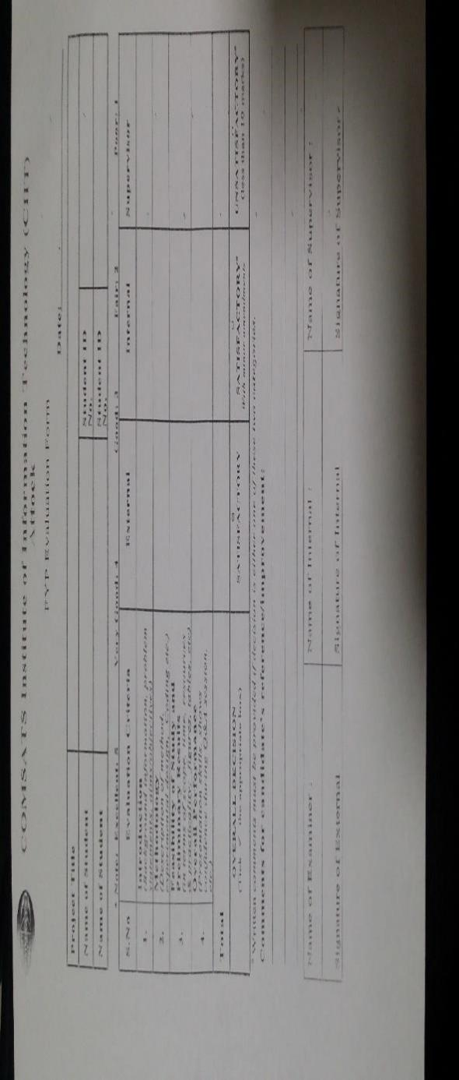

Figure 2. 1**FYP Evaluation System**

## 2.2 FYP Management System

FYP management system is web based application which working quite close to our project application. ’FYP Management System’’ in this project we will tries to develop an online platform which facilitates the final year projects (FYP) student to communicate with their supervisor more efficiently. In the FYP Management System, each user can registered and login to their profile through their registration id and password. This will help the student to upload their proposal and documentation to the system and view any notification in their message box in the profile. Supervisor registers their student. With the help of this system, student and supervisor view the deadline about the FYP activities. But in this system, the selection of supervisor is not based on his expertise.

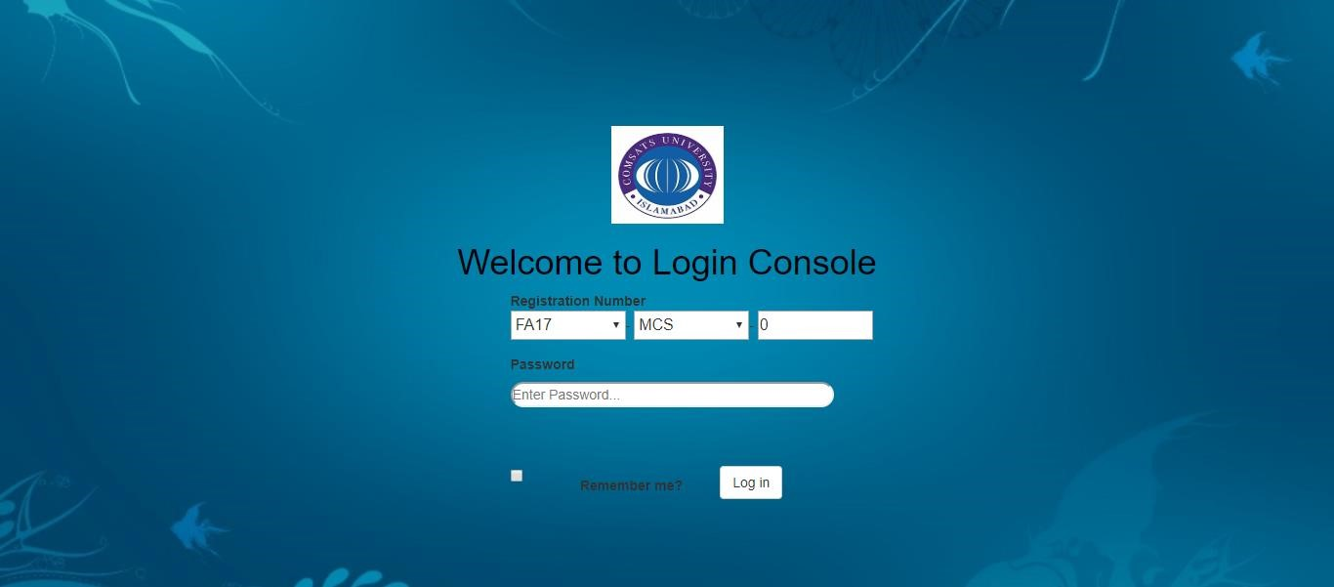

Figure 2. 2 FYP Management System

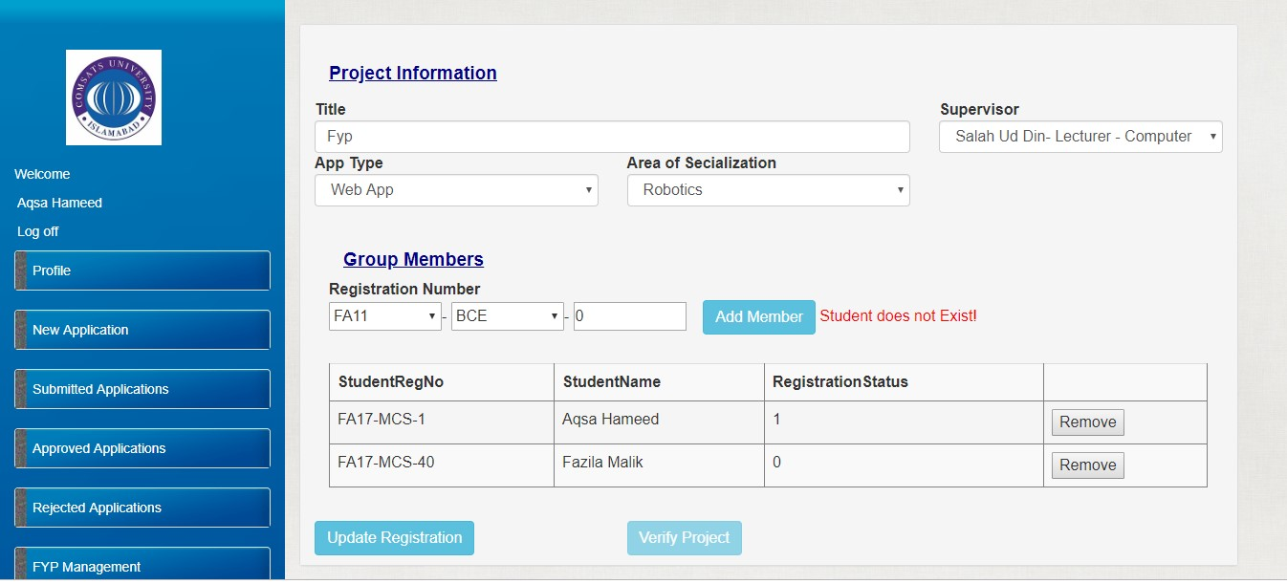

Figure 2. 3 **Project Registration view**

**2.3 Field Master Supervisor**

Field Master Supervisor is an Android application which uploaded on Google play store by a random person. This android based application which working quite close to our project application. In this application, Firstly all the supervisors need to register into the system using registration form, then registered supervisors can login into the system using their username and password to get authenticated. Field master supervisor system will provide profile of supervisors, list of all past team task which they supervised. Field master supervisor allows the mangers to supervise their team remotely. But in his system does not have a selection of supervisors.

|  |  |
| --- | --- |
|  | *c4eda0fe-7898-4b60-aa33-b0a9a2fde190 (1)* |

Figure 2. 4 Field Master Supervisor and Supervisor’s Dashboard

|  |  |
| --- | --- |
|  |  |

Figure 2. 5 Supervisor’s Dashboard and Supervisor’s Dashboard

**2.4 UTAR and MMU FYP portal**

UTAR and MMU FYP portal is web based application which working quite close to our project application. Both of them have the announcement and update portion for the students taking final year projects. In MMU university portal the students can feedback on the portal to the management team. MMU also have the feature to search the supervisors based on the project title.

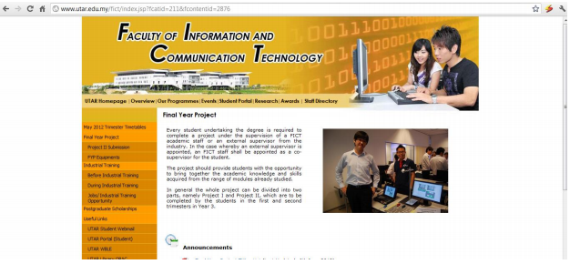

Figure 2. 6 UTAR FYP portal

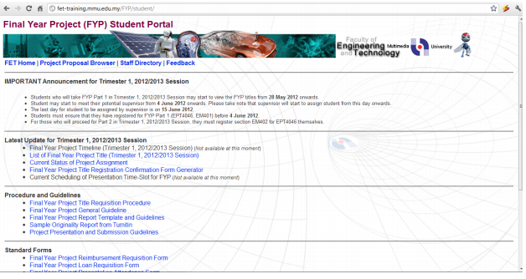 Figure 2. 7MMU FYP portal

Table 2. 1 Comparison Table

|  |  |  |  |  |  |
| --- | --- | --- | --- | --- | --- |
| **Features** | **Supervisor’s Profile with details** | **Project ideas posted by supervisor** | **Provide all available supervisor’s list** | **Vacant-**  **occupied slots of supervisors** | **Student’s feedback**  **About supervisors** |
| Field-Master Supervisor selection | Yes | No | Yes | No | No |
| FYP Evaluation System | Yes | No | No | No | No |
| FYP-Management System | Yes | No | Yes | No | No |
| MMU FYP portal | Yes | No | No | Yes | No |
| Supervisors Xpress | Yes | No | Yes | No | No |
| Schoolgirl supervisor Extended | Yes | No | Yes | No | Yes |
| UTAR FYP portal | Yes | No | No | No | No |
| Supervisor Selection  System (Own App) | Yes | Yes | Yes | Yes | Yes |

# 

# Chapter 3

# Requirement Specification

**3 Requirement Specification**

In this chapter we explain the services, features and operations that our project application in complete details. In this chapter we explain our system functional and non-functional requirements in form of paragraph of statements and in upcoming chapters we will define system requirements graphically with the help of use cases and other diagrams. Requirements are gathered to document analysis and interviewing techniques. The main reason to choose these techniques is unavailability of exact same system. It is so, because of security and privacy of the universities that have similar systems.

“Systems that have information about students, projects and supervisors will not be published to the public.” (WIFI notes,2012)

Another reason to chose interview as requirement gathering technique is that it would be enough and detailed to interview the actual users of the system because they will be using the system. The actual user will be able to precisely describe the requirement of the system.

**3.1 Functional Requirements**

Functional requirements are the essential services that a system should do and how a developing system should react to specific inputs and how the output would be generated. In other words functional requirements specify the functionalities, features or the use of system from the perspective of its users or domain.

**3.1.1 Students Registration**

Table 3. 1 FR of Students Registration

|  |  |
| --- | --- |
| **Identifier** | FR-01: Students Registration |
| **Rationale** | To save the record of each user separately. |
| **Summary** | Students will create their account by providing their details. |

**3.1.2 Sign In for Student**

Table 3. 2 FR Student Sign In

|  |  |
| --- | --- |
| **Identifier** | FR-02: Student Login |
| **Rationale** | To keep the record of signed in user for different operations in application and for security reason. |
| **Summary** | Students will enter their email and password and there is a mechanism that will determine if user is registered to application or not. |

**3.1.3 Modify Profile**

Table 3. 3 FR Modify Profile

|  |  |
| --- | --- |
| **Identifier** | FR-03: Modify Profile |
| **Rationale** | Users will need to change their profile for privacy issues or any other personal data. |
| **Summary** | User can modify his/her profile details like password, image, name . |

**3.1.4 View area of interest**

Table 3. 4 FR View area of interest

|  |  |
| --- | --- |
| **Identifier** | FR-04: View area of interest |
| **Rationale** | Students need to see the list of faculty members according to their expertise. |

**3.2 List of supervisors**

Table 3. 5List of supervisors

|  |  |
| --- | --- |
| **Identifier** | FR-05: list of supervisors |
| **Rationale** | Students can view list of all registered supervisors of related field. |
| **Summary** | Student can scroll list of supervisors of different fields and choose one of them and view his/her profile then send request. |

**3.2.1 Supervisor’s Registration**

Table 3. 6 FR Supervisor’s registration

|  |  |
| --- | --- |
| **Identifier** | FR-08: Supervisor’s registration |
| **Rationale** | To save the record of each user separately. |
| **Summary** | Supervisor will create their account by providing their details. |

**3.2.2 SignIn for Supervisor**

Table 3. 7 FR Supervisor Sign In

|  |  |
| --- | --- |
| **Identifier** | FR-02: Supervisor Login |
| **Rationale** | To keep the record of signed in supervisor for different operations in application and for security reason. |
| **Summary** | Supervisor will enter their email and cell number and there is a mechanism that will determine if user is registered to application or not. |

**3.2.3 Add own idea**

Table 3. 8 FR Add own idea

|  |  |
| --- | --- |
| **Identifier** | FR-06: Add own idea |
| **Rationale** | Supervisor can add His/Her own idea of final year project. |
| **Summary** | Supervisor can upload new ideas along with some details in the form of abstraction. |

**3.2.4 View Student’s requests**

Table 3. 9 FR view student’s requests

|  |  |
| --- | --- |
| **Identifier** | FR-02:View students requests |
| **Rationale** | Supervisors view student’s requests and then accept or reject them. |
| **Summary** | Students view Supervisor’s profile then send requests and supervisor can reject or accept their requests. |

**3.2.5 Chatting**

Table 3. 10 FR Chatting

|  |  |
| --- | --- |
| **Identifier** | FR-13: Chatting |
| **Rationale** | Students can chat with Supervisor for better communication. |
| **Summary** | Student can select supervisor from list and chat with them. They can also share pdf documents etc. |

**3.3 Admin**

Table 3. 11 FR Admin

|  |  |
| --- | --- |
| **Identifier** | FR-13: Admin |
| **Rationale** | To save the record of each user separately and approve users. |
| **Summary** | Admin login into the system and monitor accounts, approve or disapprove users,manage repository,add,disable batches also |

**3.3.1 Project’s repository**

Table 3. 12 FR Project’s repository

|  |  |
| --- | --- |
| **Identifier** | FR-13: Project’s repository |
| **Rationale** | To save the record of previous projects. |
| **Summary** | All projects stored in this repository along with short detail of abstraction.Selected projects add with previous projects after completion and stored in this repository |

## 3.4 Non-Functional Requirements

These requirements specify the criteria that can be used to judge the operation of a system, rather than specific behavior. It ensures the quality of a software. It essentially specifies how the system should behave and the constraints upon the system.

**3.4.1 Validation**

Table 3. 13 NFR Validation

|  |  |
| --- | --- |
| **Identifier** | NFR-01: Validation |
| **Rationale** | To validate application users and details that user can enter while login or sign up. |
| **Summary** | When user can create new account the validations are require to ensure that user can enter details according to following pattern. |

**3.4.2 Security**

Table 3. 14 NFR Security

|  |  |
| --- | --- |
| **Identifier** | NFR-02: Security |
| **Rationale** | To secure the data and privacy of proposed application users. |
| **Summary** | Registered users data are saved securely in firebase and no user will be able to access the data of any other user. |

**3.4.3 Usability**

Table 3. 15 NFR Usability

|  |  |
| --- | --- |
| **Identifier** | NFR-03: Usability |
| **Rationale** | System can be easy to use by all of his users and organized in such manner that user errors will be decreased. |
| **Summary** | Application has user friendly and understandable enough by all users. So users can easily perform all operations. |

**3.4.4 Availability**

Table 3. 16 NFR Availability

|  |  |
| --- | --- |
| **Identifier** | NFR-04: Availability |
| **Rationale** | To ensure system is available to its users all time. |
| **Summary** | System will be available to users all the time if there is an internet connection. Internet is required for system availability. |

**3.4.5 Performance**

Table 3. 17 NFR Performance

|  |  |
| --- | --- |
| **Identifier** | NFR-05: Performance |
| **Rationale** | System performance will be efficient. |
| **Summary** | Average response time of system is shorter so users don’t get bored or frustrated by application and left to use it. |

# 

# Chapter 4

# Project Design

## 4 Project Design

Project design is phase in which we discuss the design of a system in complete details with the help of different diagrams. For every system for every system to work correctly or properly, the design of that system must be correct. Project design helps to minimize major risks of system development. Following chapter describes the design of **Supervisor Selection System**. We use many diagrams in this chapter for increasing the understandability of our system.

## 4.1 Use Case Diagrams

Use case diagram represents the system with other elements those are involved in system.

### 4.1.1 Use Case for Students

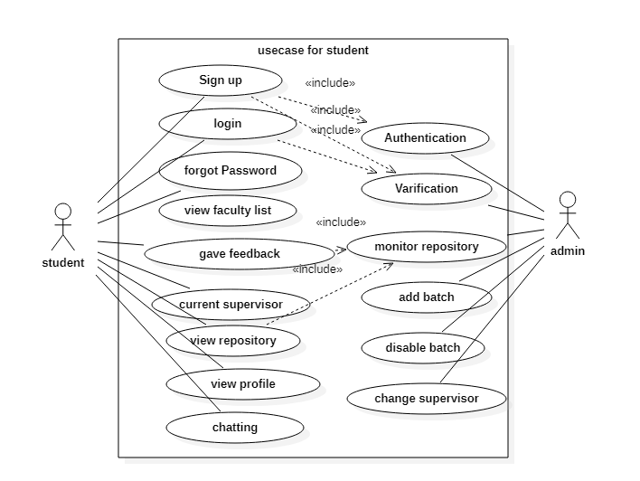

Figure 4. 2**Use Case for Students**

### 4.1.1.1 Sign up

Students sign up by filling the page write their email and password .if email is authentic then added in database if email is already register then display a message that already registered.

### 4.1.1.2 Login

Students can login by writing email and password, if same then login successfully otherwise incorrect details message appeared.

### 4.1.1.3 Forgot password

If student forgot password App provide the facility to correct it which required correct email which already registered in firebase.

**4.1.1.4 View list**

After successfully registration, student get list of supervisors according to platform choices.

### 4.1.1.5 Select supervisor

Students select one of them according to interest

### 4.1.1.6 View profile

Student view supervisor’s profile ,firstly check His/Her numbers of available slots select their proposed ideas of Fyp or student also add his/her own idea of fyp on the basis of interest.

### 4.1.1.7 Send request

Student send request to selected supervisor.

**4.1.2 Use Case for Supervisor**

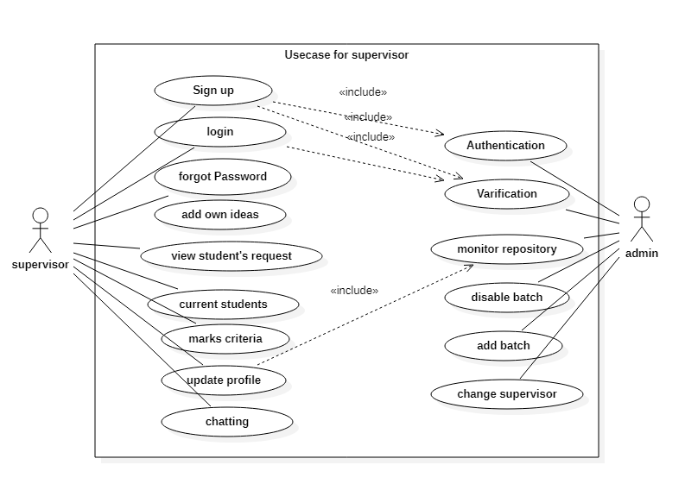

Figure 4. 3 Use Case for Supervisor

### 4.1.2.1 Sign-up

Supervisor enter details and credentials and credentials submitted in firebase for check authentication.

### 4.1.2.2 Login

Supervisor can login by writing details and password login is used for verification, if details are match with the firebase system then supervisor login successfully otherwise incorrect details message appeared.

### 4.1.2.3 View and update profile

Supervisor view profile and update it by including their available slots ,current fyp students list and also offer new ideas,check students requests.

### 4.1.2.4 View student’s requests and chatting

Supervisor check new requests of final year students then accept and also discuss with them in detail through chat room.

### 4.1.2.5 Marks criteria

Supervisor also include marks of final year project of previous students which is very helpful for new students in the selection process of supervisor.

## 4.2 Activity Diagram

Activity diagram represents the flow of activities and actions. These can be shown in it.

## 4.2.1 Student Activity Diagram

## 

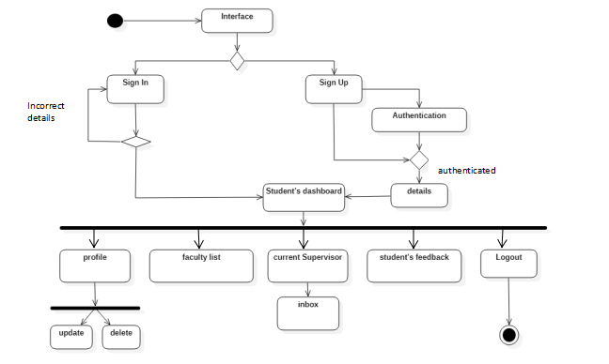

Figure 4. 4 Activity Diagram for Student

Above figure show the activity of student in supervisor selection system.First of all student login screen appear for students.if he or she correctly type details with password and after authentication process he or she will be added or registered in System .After successfully registration dashboard appear as profile which included list of supervisors including His/Her specialization and free slots student can select one of them and send request.

### 

### 4.2.2 Supervisors Activity Diagram

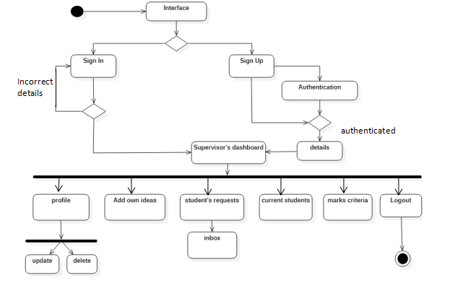

Figure 4. 5 Activity Diagram for supervisor

Above figure show activities of supervisors. First of all login screen appear if then after authentication and verification process supervisor view faculty member dashboard ,ownprofile in which He/She view student’s requests and also new student’s requests.

## 4.3 Sequence Diagrams

Sequence Diagrams show elements as they interact over time and they are organized according to object (horizontally) and time (vertically).

## 4.3.1 Students Sequence Diagram

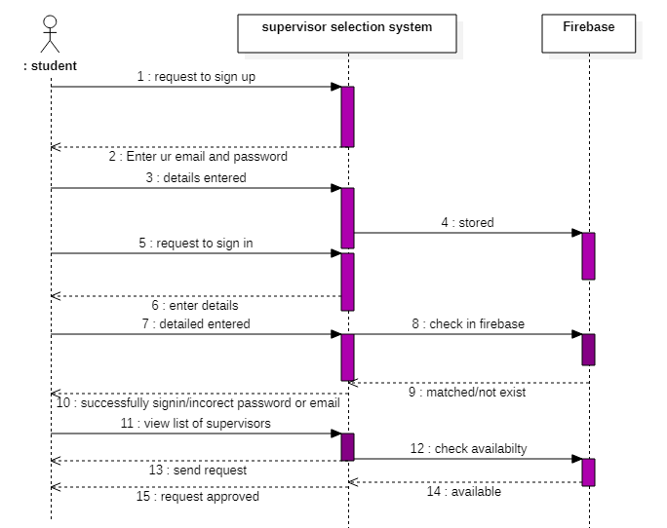

Figure 4. 6 Sequence Diagram of Students

Above figure shows sequence of student’s all activities that how he/she entered in this Application by fulfilling the requirements .First of all student requests to sign up on the basis of email and password after entering the detail record would be stored then he/she get sign in and after verification He/she select any supervisor check available number of slots and then send request.

### 4.3.2 Supervisors Sequence Diagram

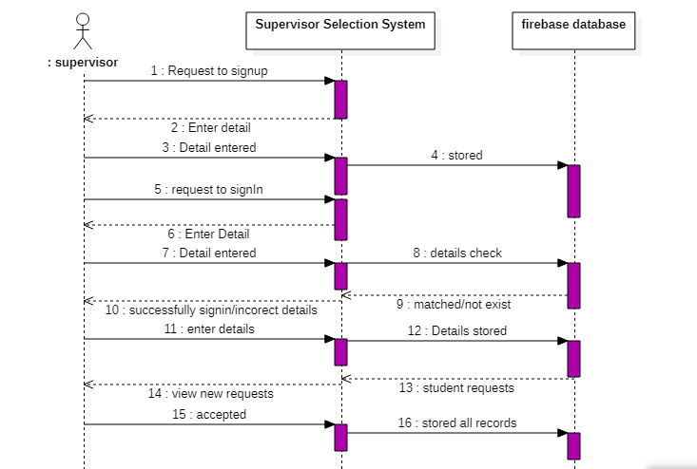

Figure 4. 7 Sequence Diagrams for Supervisor

Above figure show the sequence for supervisor.First of all supervisor request to sign up and then after authentication and verification supervisor view His/Her profile and student’s requests also update His/Her profile and records store automatically in firebase,as previous project’s records along with their marking summary.

## 

## 4.4 DFD (Data flow diagram 0 Level)

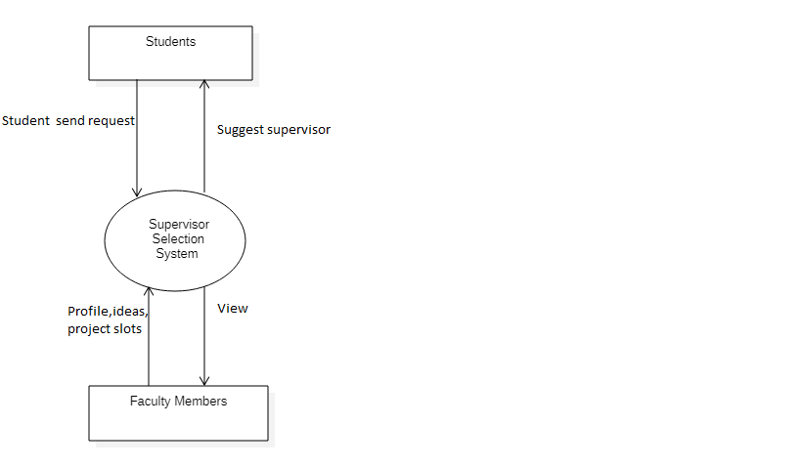

Figure 4. 8 DFD (Data flow diagram 0 Level)

Above figure shows the basic working of supervisor selection system in which a student get supervisor and can send request to supervisor through selection system and on the other hand faculty members interact with selection system after successfully registration supervisor view and edit His/Her profile by adding new ideas time to time and available slots also mentions and student can view it easily and supervisor handled student’s requests accordingly.

## 4.5DFD (Level 1 diagram)

A level 1 data flow diagram (DFD) is more detailed than a level 0 DFD. This is deep view of Supervisor Selection app functionalities. All functionalities are given in this deeply.

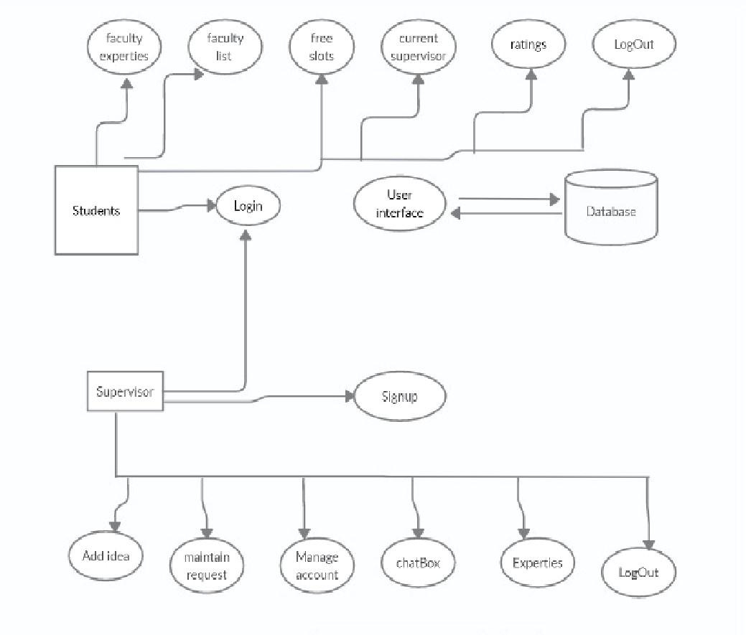

Figure 4. 9 DFD (Data flow diagram 1 Level)

# 

# 

# Chapter 5

# IMPLEMENTATION

# 5 IMPLEMENTATION

In this chapter we are going to discuss about the tools and technologies that we used during the development of the project. The implementation phase is important because at this stage the idea start converting to a physical form. Each module of our project will be developed in this phase. Each module will be developed in separate function which leads to independency. Code modification is made easy by creating modules. Also, bugs can be fixed easily. Reusability is also a factor that modules provide.

## 5.1 Tools and Techniques:

Tools are essential requirement for software development, a software developer cannot write programming code without tools. Technologies are also essential for development of software. Technologies provide basic building blocks for software development.

**5.1.1 Languages**

* Java[17] (For back end coding)
* XML[12] (For front end designing)
* Python

**5.1.2 Data Access**

* Firebase Database[1][4]

**5.1.3 Software Requirements**

* MS Word
* MS PowerPoint
* Start UML

**5.1.4 Hardware Requirements**

* Intel® Core™ i5
* Android cell phone (Minimum Lollipop 5.0 version OS)

**5.1.5 Tools**

* Android Studio[12]

**5.1.6 Android Studio**

It is a software that is designed for special purpose of android system. On 2013, 16 May android studio was announced at the Google I/O conferences by Google products manager. Following are the features provided in current version of android studio

* It provides android specific refactoring (A process of restricting existing computer code).
* It supports to build android wear applications.
* It also have Android virtual device to run applications in android studio.
* It have Gradle based built support.

### 5.1.7 Android Gradle Plugin

Android gradle plug-in contains several features that are helpful in building specific android applications. In android studio there are plug-in and gradle, build system of android studio is based on gradle and plug-in can be run indecently or updated separately. Whenever android studio is updated a prompt message is displayed to upgrade android plug-in for gradle.

### 5.1.8 Android Application SDK

For our Android application API 15 is used. Minimum API is 15 required to build Supervisor selection project in Android studio.

### 5.1.9 Engineering Diagrams

Engineering diagrams are data flow diagram (DFD), Activity diagram, Sequence diagram, Use case Diagram. These all diagrams are already done in chapter 4.

**5.1.10 Development modules**

When engineering diagrams are completed, we started working in android studio.

## 5.2 User Interface

As our project is an android application so it is necessary to create interactive and understandable user interfaces, so everyone can easily use the application. It is important to develop creative and responsive screens that can target every android device. Below are the screenshots of screens of our project application.

**5.2.1 Splash Screen**



Figure 5. 1 Splash Activity

Figure 5.1 shows the first screen of an application. This screen is called “splash screen”. When we run the application on our android device first we see splash screen for few seconds then we move to the main activity screen of our application.

#### Login/signup Activity

Registration page appears when User select himself as a user. In this page user have to enter the email and password, user move towards tracking activity as shown in figure and on clicking login button user move towards login page after proper verification.

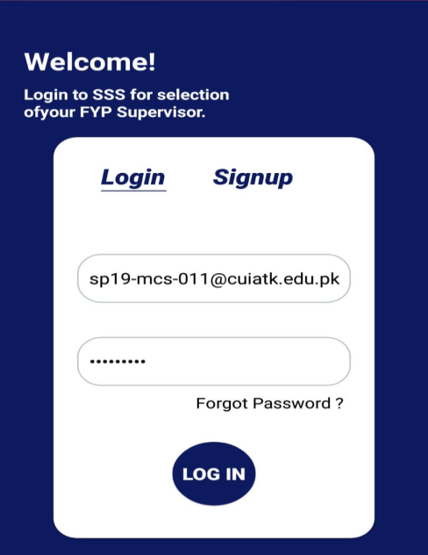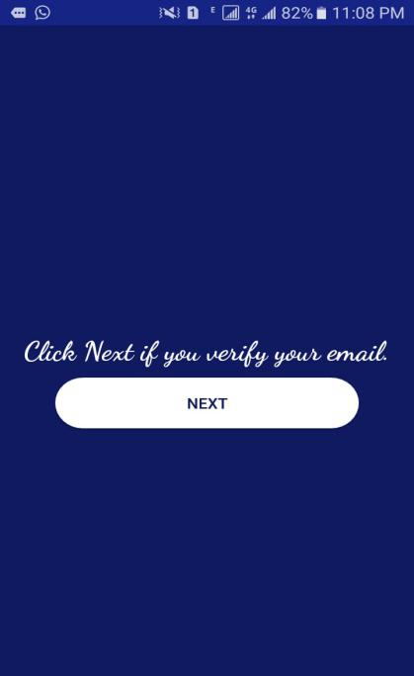

Figure 5. 2 Login Signup(a) verified(b)

#### Student Dashboard

Students dashboard is Given For student . All activities related to students are in this phase .As firstly faculty list is shown on the basis of different fields. As shown in figure.

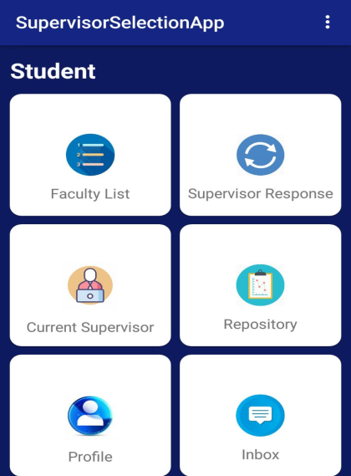

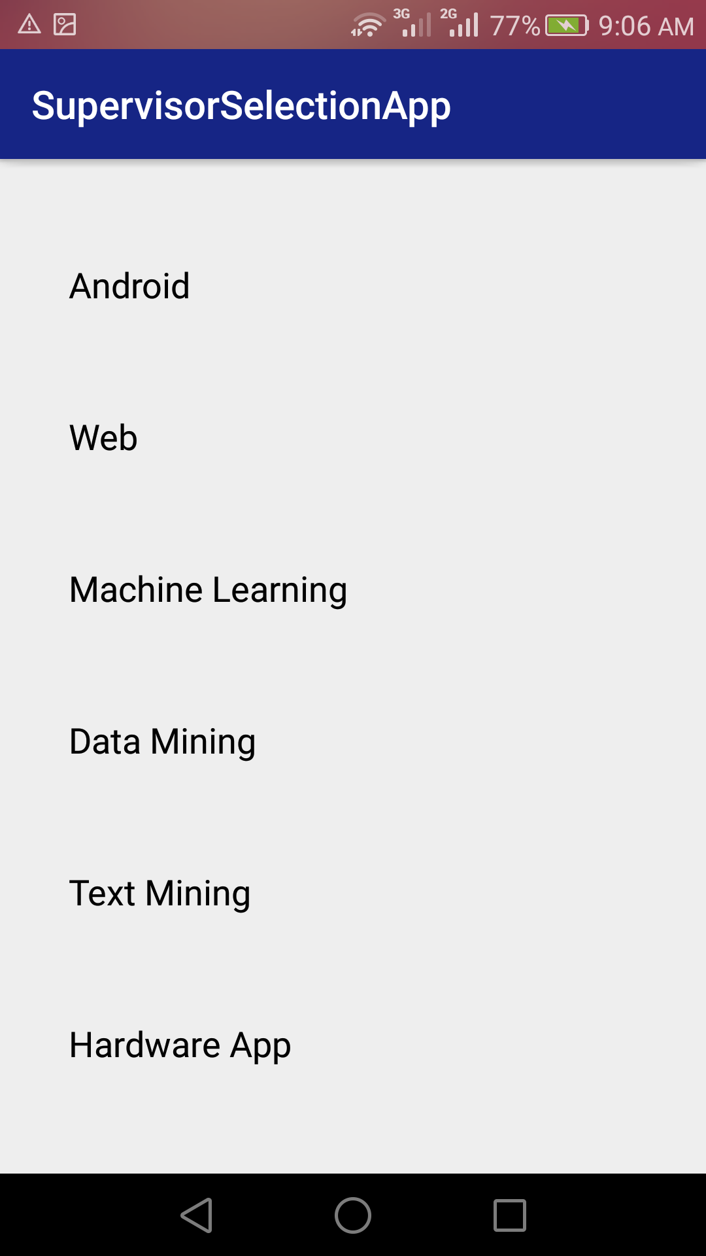

Figure 5. 3 student dashboard (a)faculty List(b)

#### SupervisorsList/repository

In Students dashboard . After selection of any field student can view supervisors of that specific field and student can also check projects repository of past projects .

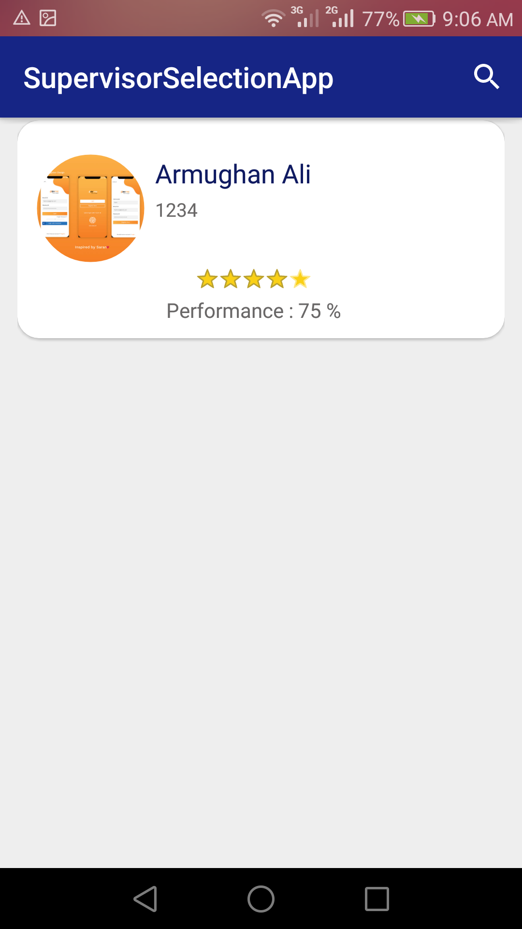 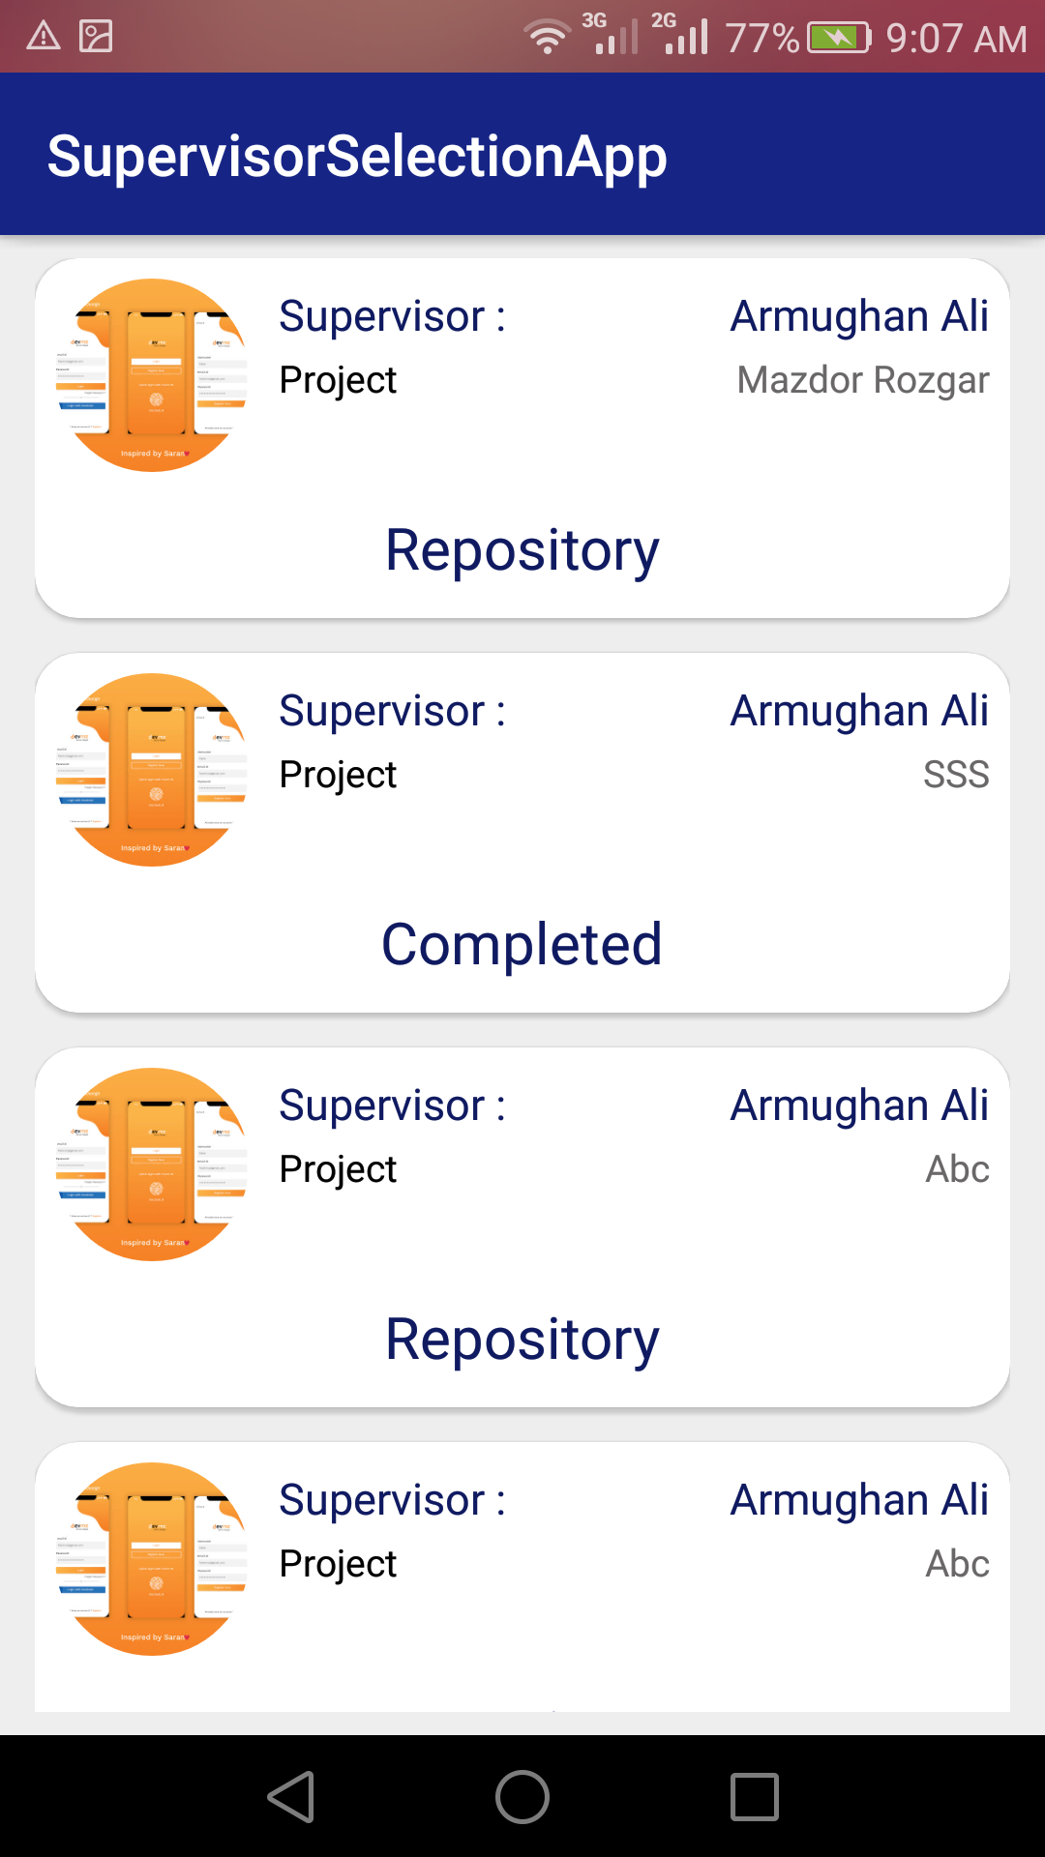

Figure 5. 4 related supervisor (a)projects repository(b)

#### Rating

Rating activity is for rate app according to user choice if user have good experience he can good rate as for bad. Maximum rating is 5 star and and 5 max stars are for good and min stars are for bad upto 1 star.

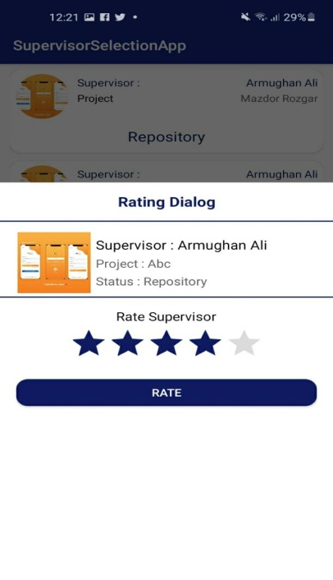

Figure 5. 5 rating

#### Supervisor Dashboard

Supervisor dashboard is Given For supervisors. All activities related to supervisors are in this phase . As shown in figure.5-8

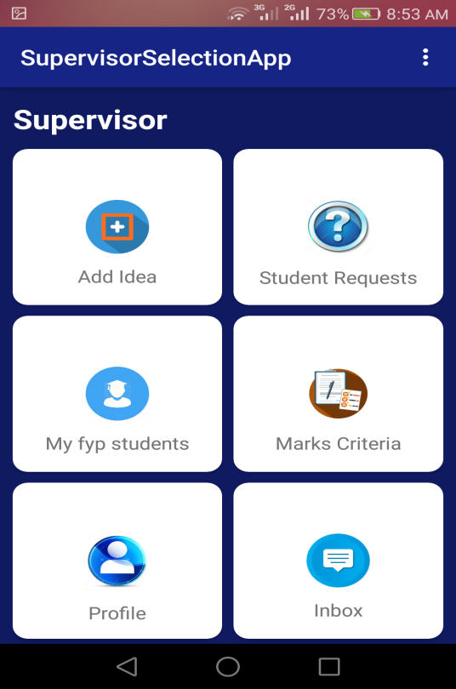

Figure 5. 6 supervisordashboard

#### Current student list

In figure 5.9 activity is for displaying list of current student that a supervisor has selected for their FYP.

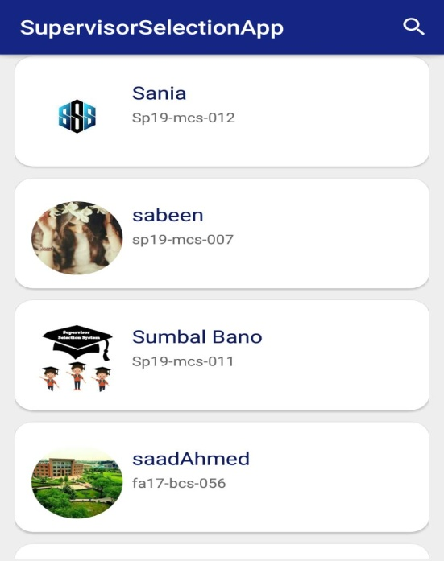

Figure 5. 7 currentstudents

#### Completed project status

This activity is displaying those students who have completed their FYP and supervisor mark their FYP as completed . This activity show to both students and supervisor as well.

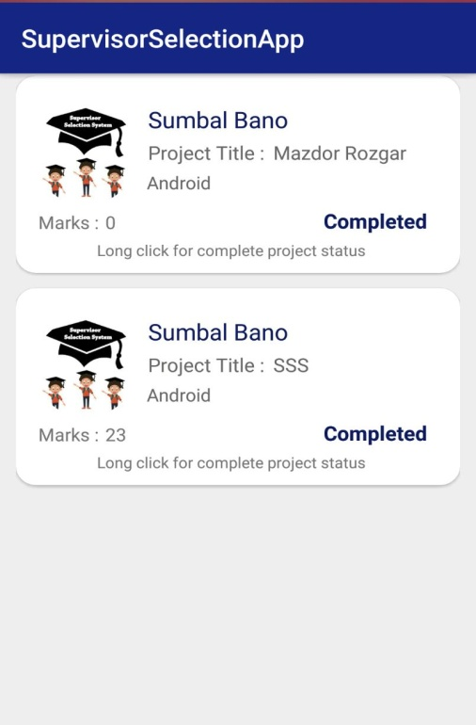

Figure 5. 8 completed projects

#### Marks Dialog

This ia dialog activity that is shown in figure 5.4 . It is for supervisor side supervisor marks as complete the student’s FYP and after marking teacher assign mask by selecting from dropdown window.

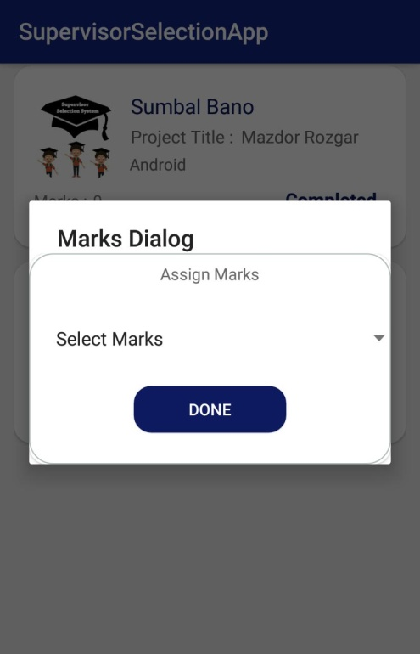

Figure 5. 9 markscriteria

#### Admin dashboard

Admin dashboard is for admin use only it is shown in figure 5.5 from this activity admin can approve user, disable user, disable batch, add batch, change supervisor and manage repository.

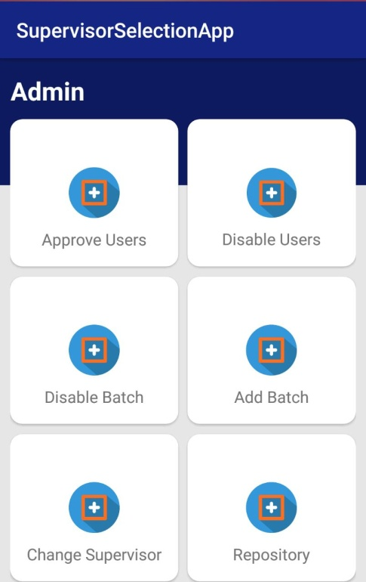

Figure 5. 10 admindashboard

#### Disable User

This Activity is for disabling user that admin does not want in it’s App

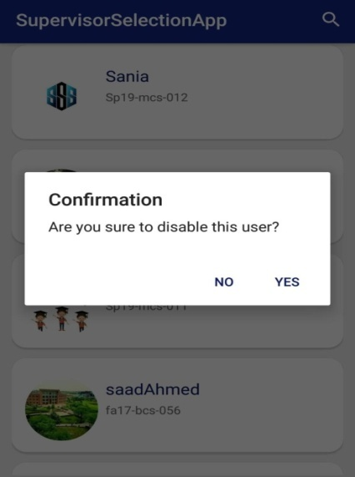

Figure 5. 11 Disable Use

#### Disable Batch

This activity is for disable any batch as shown in figure 5.7 when admin click on disable batch a pop up will appear for confirmation or cancel. Admin select according to his choice.

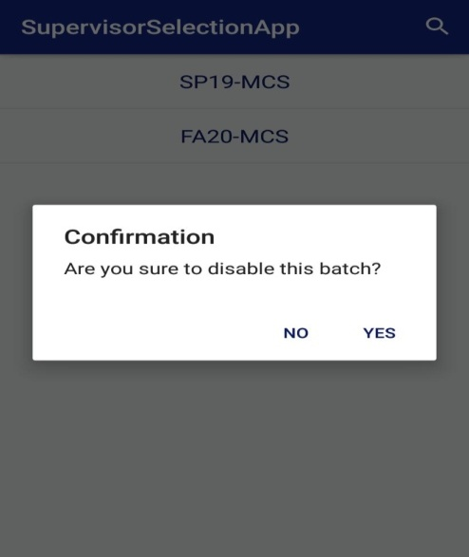

Figure 5. 12 Disable batch

# Chapter 6

# EVALUATION

# 

# 6 Evaluation

In this chapter, we evaluate our android application by applying different test cases to check the working of application It is a primary goal to check the results of all modules that whether these modules are working properly or not. Throughout development it is necessary to check the effectiveness of the system we must have to perform some evaluation techniques. It is important because we must check whether the system is working properly or not and to examine that the requirements we have mentioned in chapter 3 are fulfilled or not. So, evaluation is beneficial for project current progress and for its future work also.

**6.1 Testing**

Testing is very important phase of the development of software system. Testing strategies are used to verify the functionalities of the system. Testing strategies are building with the help of different test cases. If test cases give the desired result then it means module working properly or vice versa. As testing is more important feature, therefore we did testing in each step of implementation. We run application in different android mobile to validate the functionality of each module.

## 6.1.1 Black box testing

Black box testing is a type of testing technique, in science black box is refer to a device which can be viewed only in terms of its input, output without knowledge of any internal working. In this type of testing tester test the behavior of system by giving input and looks output on the screen. They are external users who test the system according to their requirements. Black box testing also considered as functional testing because testers just check the functionality of the system that they are getting the desired output when they insert input commands. They don’t know that how the program arrives at those results. There are many advantages of black box testing some of them are:-

* Testers (External users) do testing according to the user’s point of view. In this way hidden errors figure out easily.
* For testing there is no need to have internal knowledge of implementation.

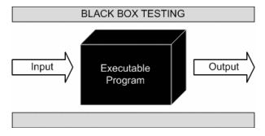

Figure 6. 1 Black Box Testing

**Application of Black Box Testing in developed System**

In black box testing as we discuss above tester did not know internal code instead he/she can run different input test cases on system and view its behavior. We ask several users such as class mates to install our project application and we also install project app on our smartphones and perform all the functionalities and record the feedbacks provided by users and note down every single response and result of testing. At basis of feedbacks by user and input test cases run by ourselves we comes to that system pass all the test cases.

## 6.1.2 White Box Testing

White box testing is also known as glass box or structural testing. This type of testing is use to test the internal structure or working of application. In this type of testing, tester has visibility of internal structure and implementation. For operating white box testing, internal perspective and good programming skills are required. We use this testing type to find out logical mistakes and to optimize the code as much as possible. In this type tester give input to system and track the path from where input is converted to output. White box testing is done by developers who have internal knowledge of coding. This testing is done parallel with coding because developers find out the main problems where the errors arise. White box testing aim is to perform testing on each and every aspect of programming logic so that no logical error or run time error arises.

Advantages are given below:

* As developers and supervisor have more internal knowledge therefore test cases are easily derived.
* Code optimization is done by finding the hidden errors.

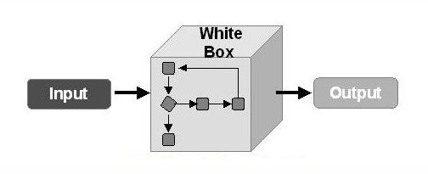

Figure 6. 2Black Box Testing

**Application of White Box Testing in developed System**

In white box testing as we discuss above tester has the knowledge of internal code of the system. We can verified our project internal code structure by our supervisor who has good quality skills in programming and also verify the system code structure by programming teacher of our university and developers. They guided us some logical improvements and we made the changes according to these improvements then again verified by the same people.

## 6.1.3 Unit testing

Unit testing is a type of testing in which units or parts of system tested separately. Unit testing is something in which each module of the system can be checked independently to examine its accuracy and performance with the pre-requisite conditions and functionality of the application mentioned in the above chapters. We checked each piece of code, the expected problems, and bugs after each phase. And if the specific module is not working accurately or according to the expected performance, we try to sort out the problem and debug it to make it working properly.

**6.1.4 Integration testing**

As the application is developed in the form of different small modules and these modules are then integrated to form a specific application as one module depends on the second module. So, we have tested these modules by integrating them by specific testing techniques to confirm the effectiveness of the system.

**6.1.5 Function Testing**

Function testing is applied or used when software system is completely developed. In this phase we can check all functionalities of application that they provide required output or not. Requirement specification document is used by tester to determine where software is meeting its requirements or not.

**Application of Function Testing in developed System**

We can perform all functionalities of application after installing project app on different smartphones. For example in our application we can authenticate mobile number, check login signup constraints and all the features of application of shopkeeper, wholesale dealer, renter, market and supplier that they are working correctly or not.

**6.1.6 System testing**

In system testing we concern with all functional demands which we have already mention in our chapter 3. Functional requirements are the major keys of any system because if anyone is failed then our system will not work correctly and may be the system will fail or crashed.” We have tested each and every functional requirement to confirm that our application satisfy all that. We also test that all the features which we add in application like request generation, up vote/down vote criteria, marking criteria etc. is working properly.

**6.2 Objective**

The main aim of testing objective is to make sure that our application is free from blunders and logical errors. And it is ready for the proper use for the users. Testing is necessary to find the errors and remove them.

## 

## 6.3 Test cases

**6.3.1 Test Case (Student Login)**

Table 6. 1 Test Case (student Login)

|  |  |  |  |  |
| --- | --- | --- | --- | --- |
| Test Case Name: Student Login Testing  Project Name: SSS  Precondition: Student must have login details  Steps: | | | | |
| No. | Step | Expected Result | Actual Result | Pass/Fail |
| 1 | Student enters his/her official email and password | System checks the validity of email and password | As expected. | Pass |
| 2 | Entered email is invalid | Show warning of invalid email address | Warning showed | Pass |
| 3 | Entered password is invalid | Show warning of invalid password | Warning showed | Pass |
| 4 | Password field is empty | Show warning” password required” | Warning showed | Pass |
| 5 | Email field is empty | Show warning” email required” | Warning showed | Pass |
| Post Condition: Login form is working properly. | | | | |

6.3.2 Supervisor Login:

Table 6. 2 2 Test Case (supervisor Login)

|  |  |  |  |  |
| --- | --- | --- | --- | --- |
| Test Case Name: Supervisor Login Testing  Project Name: SSS  Precondition: Supervisor must have login details  Steps: | | | | |
| No. | Step | Expected Result | Actual Result | Pass/Fail |
| 1 | Supervisor enters his/her email and password | System checks the validity of email and password | As expected. | Pass |
| 2 | Entered email is invalid | Show warning of invalid email address | Warning showed | Pass |
| 3 | Entered password is invalid | Show warning of invalid password | Warning showed | Pass |
| 4 | Password field is empty | Show warning” password required” | Warning showed | Pass |
| 5 | Email field is empty | Show warning” email required” | Warning showed | Pass |
| Post Condition: Login form is working properly. | | | | |

6.3.3 Admin Login:

Table 6. 3 Test Case (Admin Login)

|  |  |  |  |  |
| --- | --- | --- | --- | --- |
| Test Case Name: Admin Login Testing  Project Name: SSS  Precondition: Admin must have login details  Steps: | | | | |
| No. | Step | Expected Result | Actual Result | Pass/Fail |
| 1 | Admin enters his/her name and password | System checks the validity of name and password | As expected, | Pass |
| 2 | Entered password is invalid | Show warning of invalid password | Warning showed | Pass |
| 3 | Password field is empty | Show warning” password required” | Warning showed | Pass |
| Post Condition: Login form is working properly. | | | | |

6.3.4 Student Sign Up:

Table 6. 4 Test Case (student Signup)

|  |  |  |  |  |
| --- | --- | --- | --- | --- |
| Test Case Name: Student Sign up Testing  Project Name: SSS  Precondition: none  Steps: | | | | |
| No. | Step | Expected Result | Actual Result | Pass/Fail |
| 1 | student enters his/her name, registration number and contact number | System takes them correctly | As expected, | Pass |
| 2 | Student enters invalid email | Show warning of invalid email address | Warning showed | Pass |
| 3 | Student enters valid email | System sends confirmation email to the entered email address | Email sent successfully | Pass |
| 4 | Password and confirm password are not equal | Show warning” password do not match” | Warning showed | Pass |
| 5 | Student uploads picture | Picture attached | As expected, | Pass |
| 6 | Student clicks submit button | Data received successfully | As expected, | Pass |
| Post Condition: Sign Up form is working properly. | | | | |

6.3.5 Email Confirmation:

Table 6. 5 Test Case (Email Confirmation)

|  |  |  |  |  |
| --- | --- | --- | --- | --- |
| Test Case Name: Email Confirmation Testing  Project Name: SSS  Precondition: sign up form submitted  Steps: | | | | |
| No. | Step | Expected Result | Actual Result | Pass/Fail |
| 1 | Entered email is authentic | Email is authentic | As expected, | Pass |
| 2 | Sends email | Email sent successfully | successful | Pass |
| 3 | Student enters verify option | Account created | successful | Pass |
| 4 | Student not enters on verify option | Show warning” you are not verified” | Warning showed | Pass |
| Post Condition: email confirmation modules works correctly. | | | | |

6.3.6 Upload Project:

Table 6. 6 Test Case (Upload Project)

|  |  |  |  |  |
| --- | --- | --- | --- | --- |
| Test Case Name: Upload Project Module Testing  Project Name: SSS  Precondition: student logged in  Steps: | | | | |
| No. | Step | Expected Result | Actual Result | Pass/Fail |
| 1 | Student enter project title, ,area of project or platform and add abstract as a description. | Data received successfully | As expected, | Pass |
| 2 | Student insert invalid Document Format | Show warning” File type is not allowed” | Warning showed | pass |
| 3 | Student clicks submit button | Uploads data and sends notification to supervisor | Successful | pass |
| Post Condition: upload module works correctly. | | | | |

6.3.7 Lists of Supervisors:

Table 6. 7 Test Case (List of Supervisors)

|  |  |  |  |  |
| --- | --- | --- | --- | --- |
| Test Case Name: List of supervisors Module Testing  Project Name: SSS  Precondition: student logged in  Steps: | | | | |
| No. | Step | Expected Result | Actual Result | Pass/Fail |
| 1 | Student enter expertise, platform | Received data | successful | Pass |
| 2 | List of supervisors is visible | List is ranked | successful | Pass |
| 3 | Click on view profile | Redirected to supervisor profile | successful | Pass |
| Post Condition: list of supervisor module works correctly. | | | | |

6.3.8 Supervisor Approve request:

Table 6. 8 Test Case (Supervisor Approve request)

|  |  |  |  |  |
| --- | --- | --- | --- | --- |
| Test Case Name: Supervisor Approve request Module Testing  Project Name: SSS  Precondition:Student send request to supervisor  Steps: | | | | |
| No. | Step | Expected Result | Actual Result | Pass/Fail |
| 1 | Request is send to supervisor | Notification is displayed | successful | Pass |
| 2 | Supervisor clicks on notification | Project approval page displayed | successful | Pass |
| 3 | Supervisor clicks on accept button | Project status is updated to accept | successful | Pass |
| 4 | Supervisor clicks on reject button | Project status is updated to rejected | Successful | pass |
| Post Condition: Supervisor approve request module works correctly. | | | | |

**6.3.9 Test Case (Chatting)**

Table 6. 9 Test Case (Chatting)

|  |  |  |  |  |
| --- | --- | --- | --- | --- |
| Test Case Name: Chatting Module Testing  Project Name: SSS  Precondition:Student send message to supervisor  Steps: | | | | |
| No. | Step | Expected Result | Actual Result | Pass/Fail |
| 1 | Send message without typing any text and send to supervisor | Please type something | Please type something | Pass |
| 2 | Send message with type something in chat field | Message sent | Message sent | Pass |
| 3 | Deleted message and check its deleted only at user own side | Deleted message is shown to other recipient in chat | Deleted message is shown to other recipient in chat | Pass |
| Post Condition: Student send message to supervisor module works correctly. | | | | |

6.3.10 Supervisor Response:

Table 6. 10Test Case (Supervisor Response)

|  |  |  |  |  |
| --- | --- | --- | --- | --- |
| Test Case Name:Supervisor response Module Testing  Project Name: SSS  Precondition: student logged in  Steps: | | | | |
| No. | Step | Expected Result | Actual Result | Pass/Fail |
| 1 | Student goes to completed project page | Previous ratings are visible | successful | Pass |
| 2 | Student enters his/her review | rating added successfully | successful | Pass |
| 3 | Review added | Review is visible | successful | Pass |
| Post Condition: Review module works correctly. | | | | |

**Chapter 7**

**Conclusion and Future Work**

## 7 Conclusion and Future work

In this chapter we discuss conclusion and future work of our project application after completing implementation and evaluation phases.

**7.1** **Conclusion**

We are developed android application which is helpful for FYP students and supervisor. This application have no bugs and also it is user friendly and working efficiently. This application is specially designed for those students who want to enroll in FYP and are searching for supervisor. It is not just for students also for supervisors. Supervisor have also hectic job to select appropriate student by setting meetings with them.

Now by this application student easily search supervisor and check his profile from predefined set of data. Students also have registration and login he/she signup and login and maintain their profiles. Student can request Supervisor and incase of any further query student can easily chat with supervisor through chatting. The main focus of the application was time saving and to simplify the activities of choosing supervisors for final year project. This application will be available for students, supervisors and admin. This application is tested on many devices. This application provide ease both to students and supervisors.

## 7.1 Future work

As we develop android application, android studio provides very interesting and useful new updates that help us to expand our project application. In future, there is a list of functionalities that can be added to this application.so that more benefits can be attained.

### Alert

System generate alert when a Student request is added.

### IOS Application

IOS is holding good number of market shares, to increase the app user we need to make IOS app too in future.

**Chapter 8**

**References**

## 8 References

[1]["Firebase - Crunchbase"](https://www.crunchbase.com/organization/firebase)*.*[CrunchBase](https://en.wikipedia.org/wiki/CrunchBase). Retrieved August 1, 2020*.*

[2] Grechanik, M. K. (2007). Recovering and using use-case-diagram-to-source-code traceability links . Proceedings of the the 6th joint meeting of the European software engineering conference and the ACM SIGSOFT symposium.

[3] ["Firebase Auth"](https://firebase.google.com/docs/auth/). Firebase, Inc. Retrieved May 19, 2016.

[4] Methods. (n.d.). Retrieved from softwaretestingfundamentals: softwaretestingfundamentals.com

[5] Methods. (n.d.). Softwaretestingfundamentals.com.

[6] Methods (n.d). Firebase developer documentation: www.firebase.developer.com/docs.

[7] Methods (n.d). Google developer documentation: www.developers.google.com/docs.

[8] [Schildt](https://www.worldcat.org/search?q=au%3ASchildt%2C+Herbert%2C&qt=hot_author), H. (2010). Java: the complete reference. New York: McGraw-Hill Education.

[9] Pressman, R. S. (2005). Software engineering: a practitioner's approach. Palgrave macmillan.

[10] ["GitHub Diversity"](https://github.com/about/diversity/report).Github.com (2008).

[11] Sengupta, S. a. ( 2006). Formalization of UML use case diagram-a Z notation based approach. International Conference on Computing & Informatics. IEEE.

[12] Google AdMob. (2006). Mobile Apps SDK(Android) : www.developer.google.com/admob/android/quick-start

[17] Schildt, H. (2014). Java: The Complete Reference, Ninth Edition. **McGraw-Hill Education.**